**BIKE SAFETY- HEALTH LESSON**

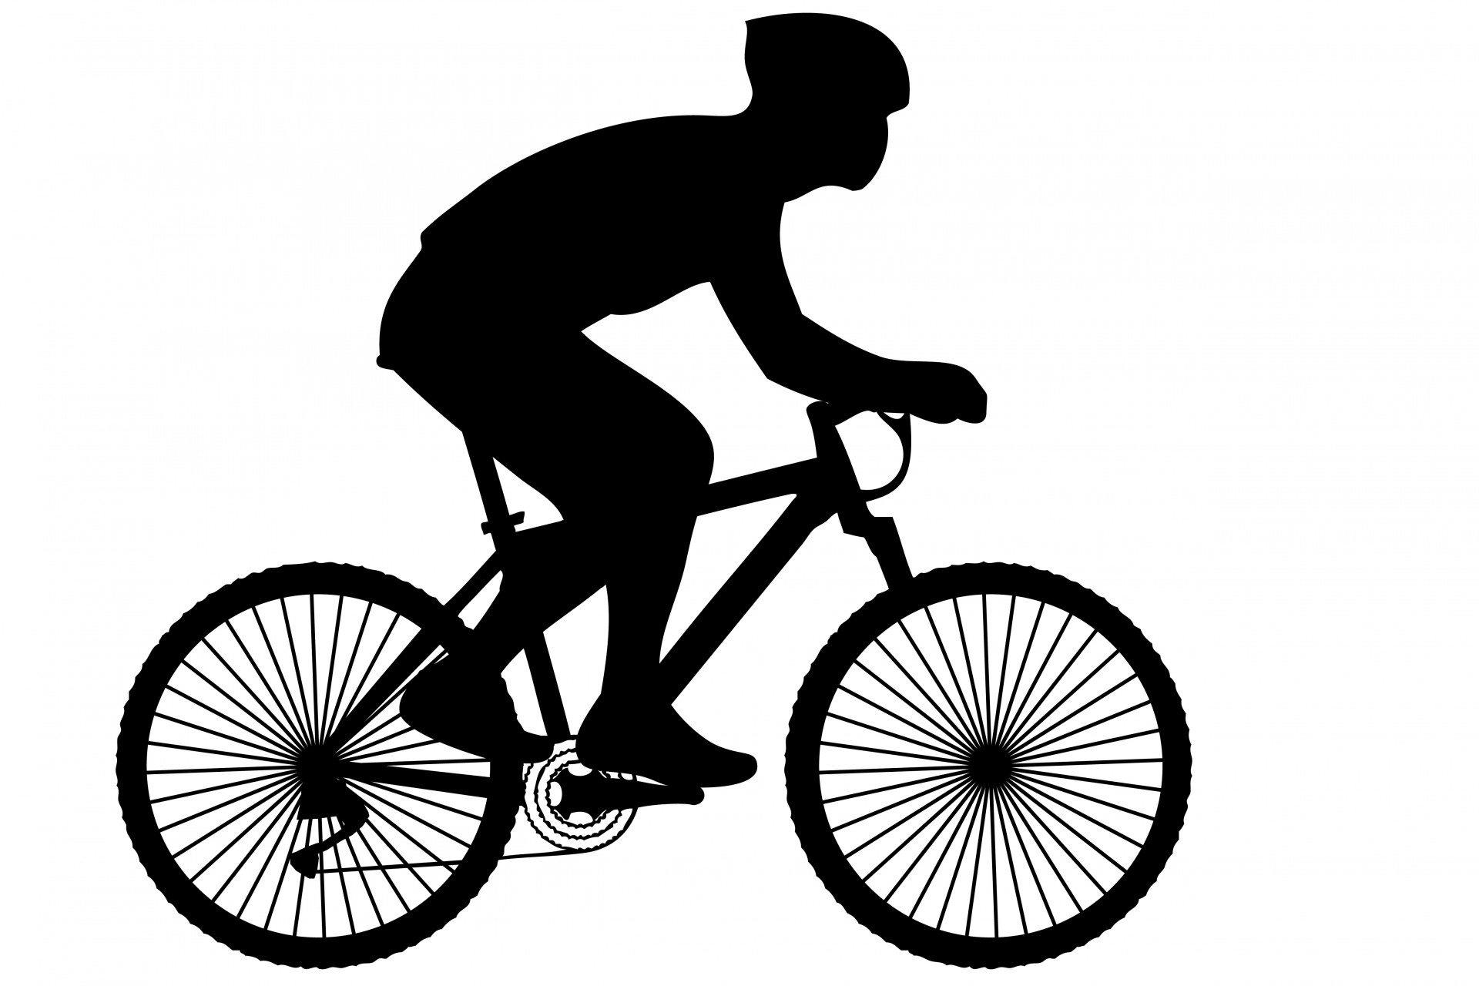

**Hi Kids,**

**Today we will be learning about bicycle safety. Riding your bike or scooter is a fun activity! Following a few safety rules is very important!**

**Bike/ Scooter Safety Rules:**

1. **Always wear an approved helmet. A helmet protects your head from injury. It is so important to wear one while you are riding. Below is a picture of a helmet. It needs to be the right size and fit for you.**

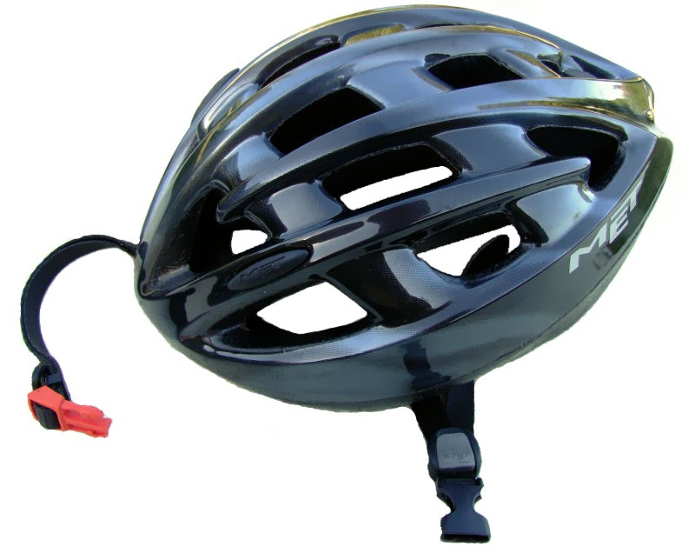

1. **Always ride in a safe area and with an adult! Always ride on the right side of the road.** 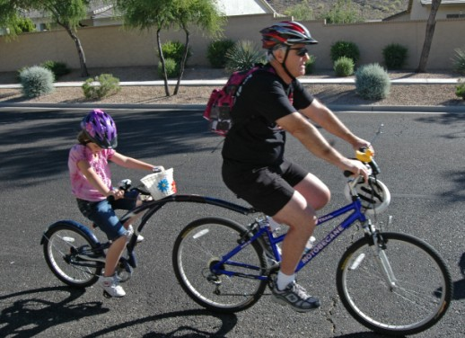
2. **Always be aware of your surroundings! Please pay attention to traffic when riding, other people and animals that might be walking! Always follow traffic signs when riding on the road.**

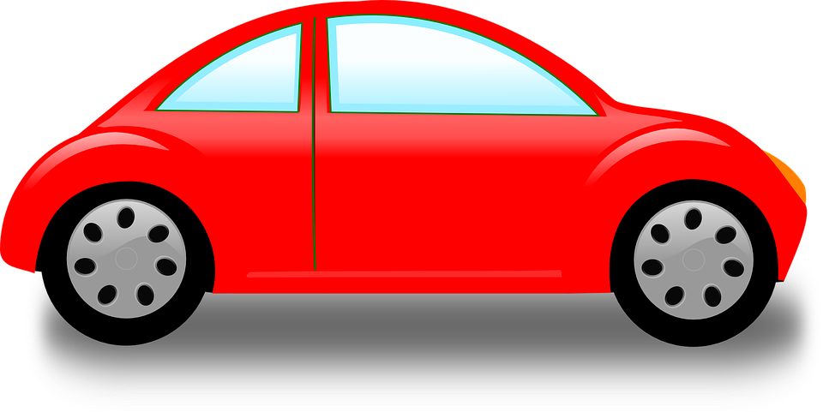 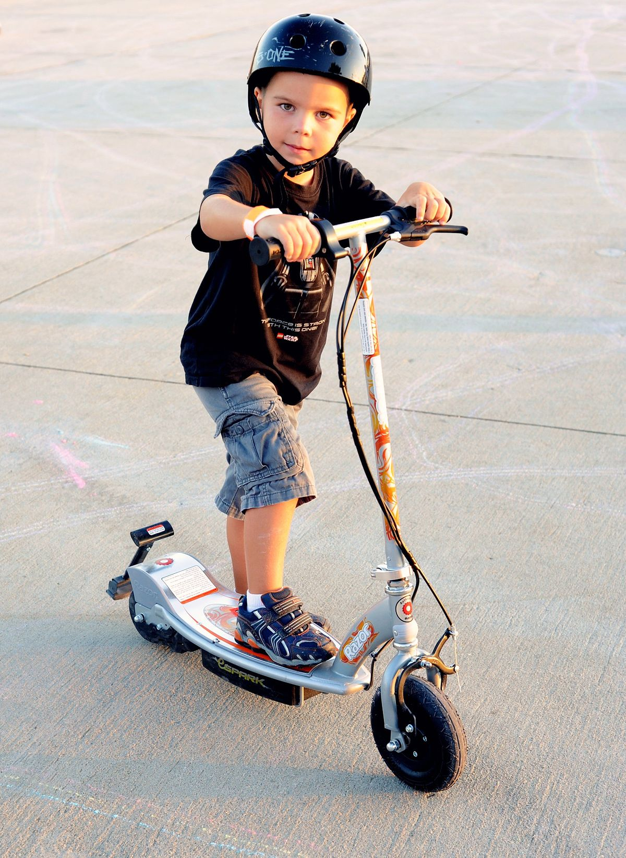



1. **Make sure you or an adult check your bike or scooter to make sure it is working properly before you ride.**
2. **Use verbal communication or hand signals if you need to.** 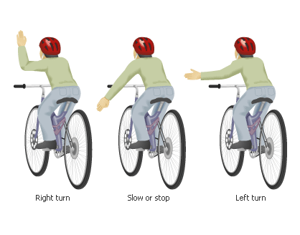
3. **Please do not ride at night. Riding at night can be dangerous**

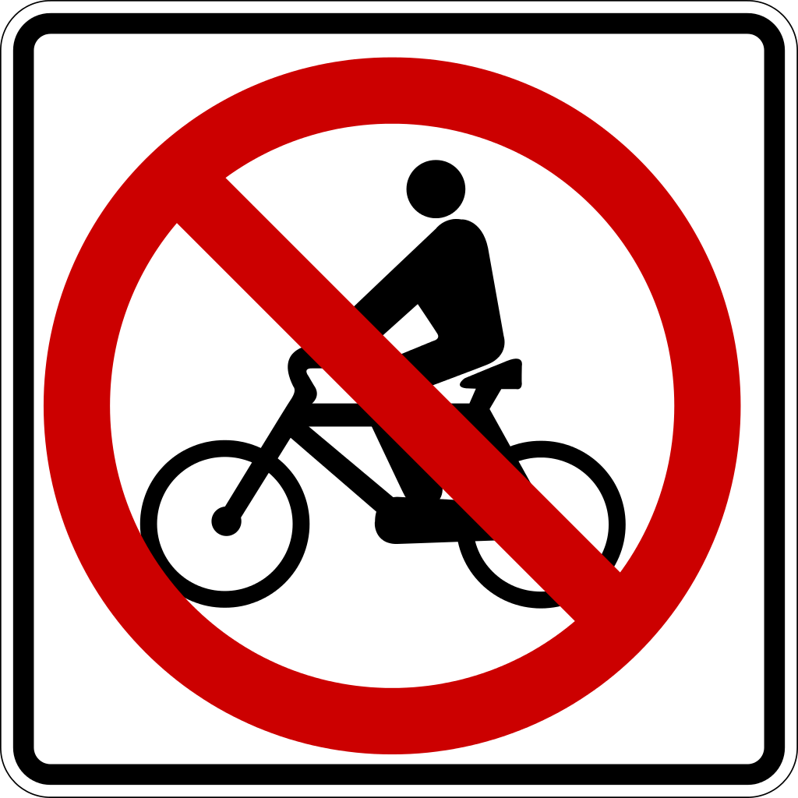 **AT** 

**Please follow these important bicycle/scooter safety rules when riding!**

**Please click on the link below to watch a short video about bike safety titled, “Bicycle Safer Journey”:**

<https://youtu.be/dkoVxBnnGko>

**When you have completed the lesson please email us or post a message on our post on school story on DOJO in the comments.** [MillerA@dvsd.org](mailto:MillerA@dvsd.org) or [FeissJ@dvsd.org](mailto:FeissJ@dvsd.org)

**Take Care,**

**Mrs. Miller and Mr. Feiss** 😊